1. **Create a database name - “Employee”.**

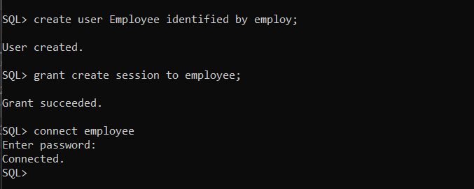

I have created a new user/database as Employee and created a session and grated to the employee.

We use create keyword to create new database/table etc.. , after creating the database we connected to the database using connect keyword and we have to enter the password to connect to the database.

1. **CREATING TABLE:**

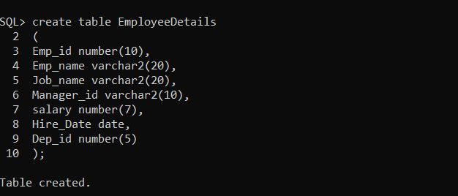

Created a table named EmployeeDetails schema and we add some attributes to the table now we have to insert the data using insert keyword;

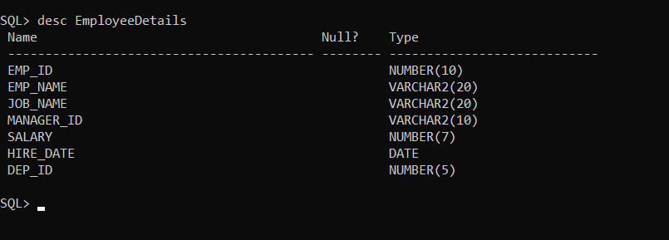

**3)INSERTING VALUES:**

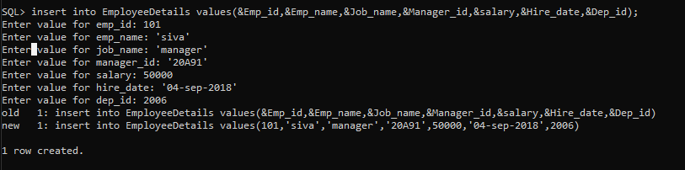

DATA INSERTED USING INSERT KEYWORD AS FOLLOWS:

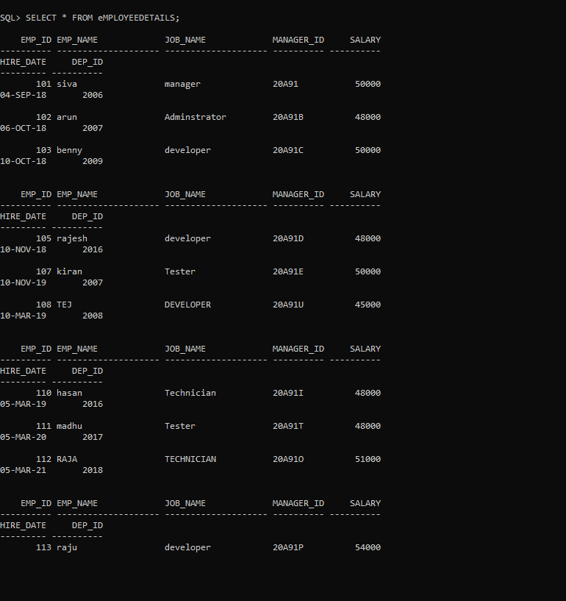

**4)SELECTING Salaries from the table**:

select salary from Employee_details;

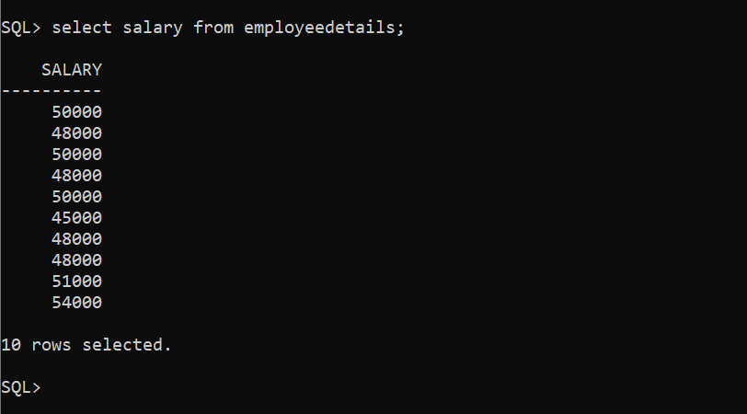

**5)SELECTING UNIQUE DESIGNATIONS(JOB_NAME):**

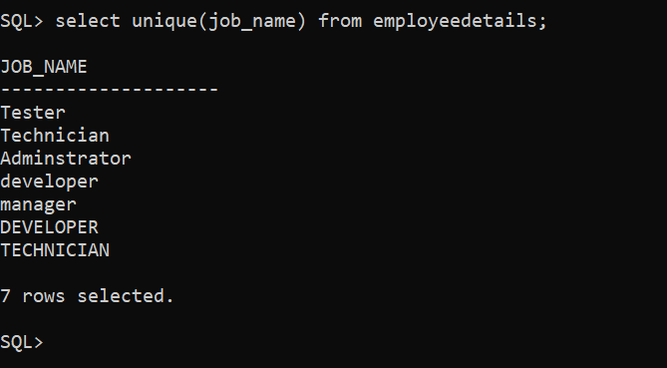

**6)UPDATING SALARY OF EMPLOYER NAME RAJ:**

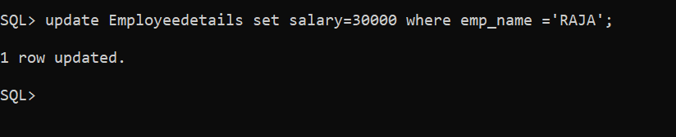

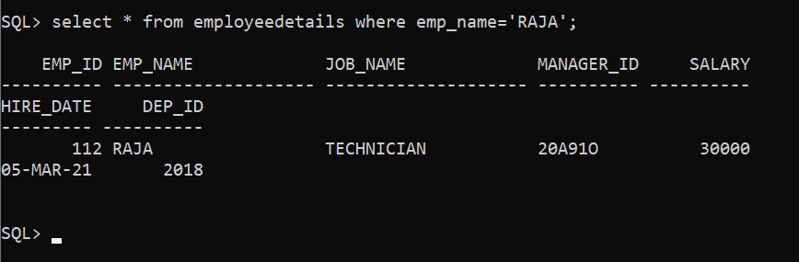

2)

1. **Create Footbal database**

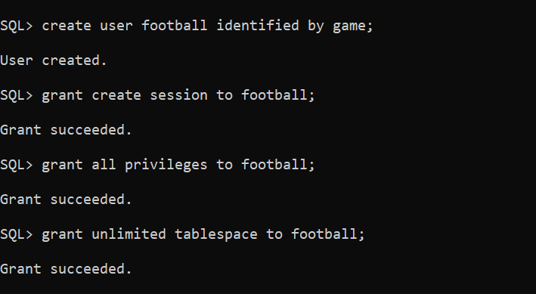

Connect to the database as bellow:

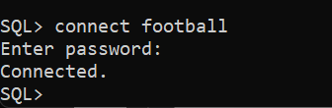

Now create a table schema to enter the data;

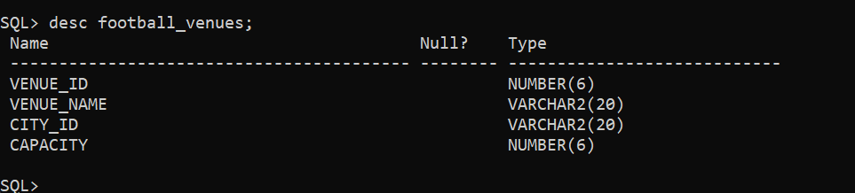

3.)Now insering the data into the database as follows:

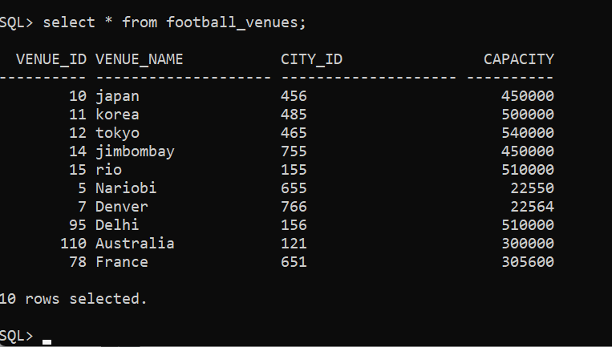

1. **Counting number of venues:**

**Output:**

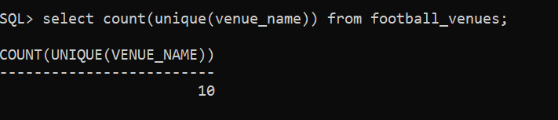

**5. List all the venue names and capacities in the format of “Location” and “Volume”.**

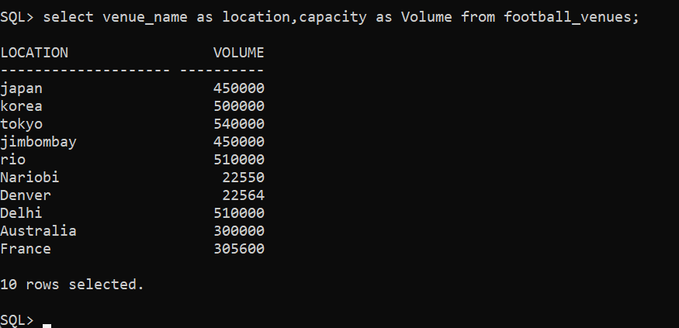

**6. Delete all the details where venue_name is equal to “Australia”**

